Project Design Phase-II
Technology Stack (Architecture & Stack)

Date | 20 June 2025
Team ID | LTVIP2025TMID52984
Project Name | FreelanceFinder: Discovering Opportunities, Unlocking Potential
Maximum Marks | 4 Marks

Technical Architecture:
The Deliverable shall include the architectural diagram as below and the information as per the table1 & table 2
Example: Freelancer finder is built using a 3-tier architecture
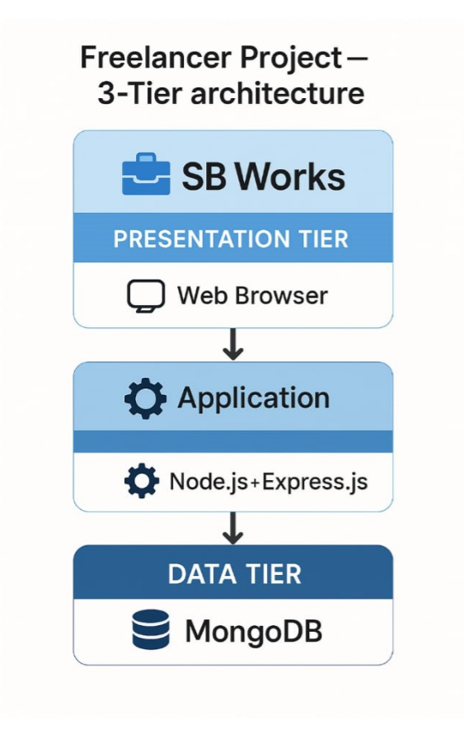
Table-1 : Components & Technologies:
S.No | Component | Description | Technology
1 | User Interface | Web UI for users. | HTML, CSS, JavaScript, React.js
2 | Application Logic-1 | Manages backend logic | Node.js, Express.js
3 | Application Logic-2 | Frontend-backend communication. | Express.js Controllers
4 | Application Logic-3 | filtering system | Express.js Controllers
5 | Database | Stores all platform data | MongoDB
6 | Cloud Database | Stores user/project content. | MongoDB Atlas
7 | File Storage | Overall system model | Multer, Cloudinary / Local FS
8 | External API-1 | For notifications. | Cloudinary API
9 | External API-2 | Not used. | —
10 | Machine Learning Model | Not used | —
11 | Infrastructure | Cloud/Local Deployment | Local Server (Node), MongoDB Atlas (Cloud)

Table-2: Application Characteristics:
S.No | Characteristics | Description | Technology
1 | Open-Source Frameworks | Open-source tools used in development | React.js, Node.js, Express.js, MongoDB
2 | Security Implementations | Access control, token-based auth | JWT, Bcrypt.js, Helmet.js, CORS
3 | Scalable Architecture | 3-tier scalable design with modular services | MERN Stack
4 | Availability | Hosted backend, database in cloud (MongoDB Atlas), supports 24/7 uptime | Cloud-hosted MongoDB Atlas, Node Server
5 | Performance | Optimized queries, component-based frontend, fast API responses | React Virtual DOM, REST API, MongoDB Indexes

